Work Report:

Here is some example of how this project was carried out with all resource that we used.

Draw a prototype:

<https://proto.io/>

Data CSV file:

What is a CSV file?

A CSV file (Comma Separated Values file) is a type of plain text file that uses specific structuring to arrange tabular data. Because it’s a plain text file, it can contain only actual text data—in other words, printable ASCII or Unicode characters.

The structure of a CSV file is given away by its name. Normally, CSV files use a comma to separate each specific data value. Here’s what that structure looks like:

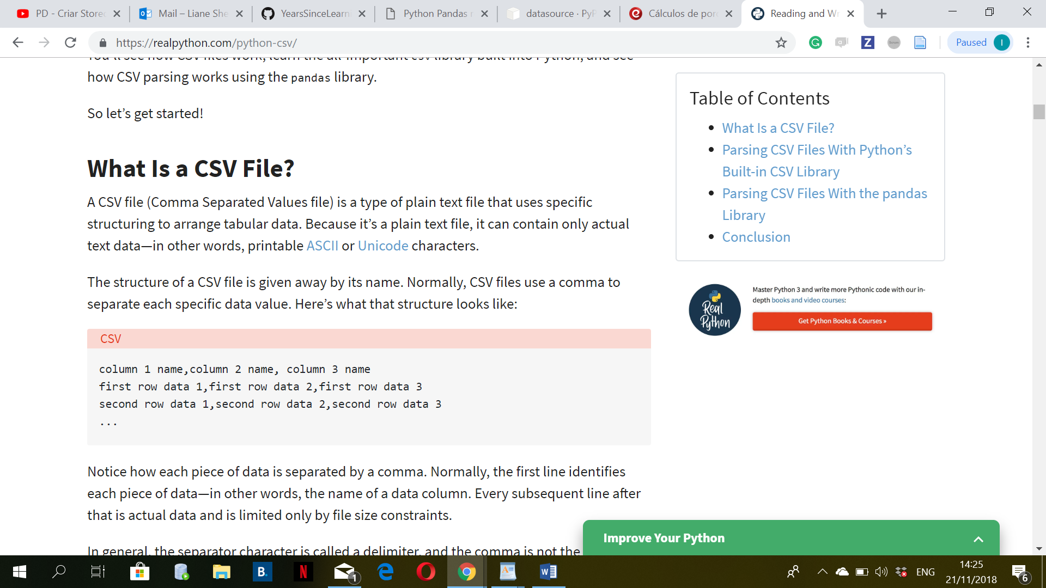

Read CSV file through Python:

import os

The OS module in Python provides a way of using operating system dependent functionality. The functions that the OS module provides allows you to interface with the underlying operating system that Python is running on – be that Windows, Mac or Linux.

<https://www.pythonforbeginners.com/os/pythons-os-module>

import csv

Reading from a CSV file is done using the reader object. The CSV file is opened as a text file with Python’s built-in open() function, which returns a file object. This is then passed to the reader, which does the heavy lifting.

A CSV is a comma separated values file which allows data to be saved in a table structured format. CSVs look like a garden-variety spreadsheet but with a .csv extension. Traditionally they take the form of a text file containing information separated by commas, hence the name.

<https://support.bigcommerce.com/s/article/Import-Export-Overview>

import csv

with open('employee_birthday.txt') as csv_file:

csv_reader = csv.reader(csv_file, delimiter=',')

line_count = 0

for row in csv_reader:

if line_count == 0:

print(f'Column names are {", ".join(row)}')

line_count += 1

else:

print(f'\t{row[0]} works in the {row[1]} department, and was born in {row[2]}.')

line_count += 1

print(f'Processed {line_count} lines.')

import sys

sys — System-specific parameters and functions. This module provides access to some variables used or maintained by the interpreter and to functions that interact strongly with the interpreter. It is always available. sys.argv. The list of command line arguments passed to a Python script.

<https://docs.python.org/3.0/library/sys.html>

Panda:

<https://www.shanelynn.ie/python-pandas-read_csv-load-data-from-csv-files/>

CSV (comma-separated value) files are a common file format for transferring and storing data. The ability to read, manipulate, and write data to and from CSV files using Python is a key skill to master for any data scientist or business analysis. In this post, we’ll go over what CSV files are, how to read CSV files into Pandas DataFrames, and how to write DataFrames back to CSV files post analysis.

Pandas is the most popular data manipulation package in Python, and DataFrames are the Pandas data type for storing tabular 2D data.

import pandas as pd

|  |
| --- |
|  |
|  | data = pd.read_csv('../database/survey_results_public.csv') |
|  | print(data['YearsCodingProf'].value_counts()) |
|  |  |
|  |  |
|  | #print(data['YearsCodingProf'].value_counts()) |
|  |  |
|  | summary = data['YearsCodingProf'].value_counts() |
|  | #print(summary["3-5 years"]) |

1. # Load the Pandas libraries with alias 'pd'
2. **import** pandas **as** pd
3. # Read data from file 'filename.csv'
4. # (in the same directory that your python process is based)
5. # Control delimiters, rows, column names with read_csv (see later)
6. data = pd.read_csv("filename.csv")
7. # Preview the first 5 lines of the loaded data
8. data.head()

pip install panda

**HTML** provides the basic structure of sites, which is enhanced and modified by other technologies like CSS and JavaScript.

**CSS** is used to control presentation, formatting, and layout.

**JavaScript** is used to control the behaviour of different elements.

<https://blog.hubspot.com/marketing/web-design-html-css-javascript>

**How to create you page examples:**

**Templets:**

HTML, CSS, JavaScript:

<https://www.w3schools.com/howto/howto_js_full_page_tabs.asp>

<https://www.w3schools.com/howto/tryit.asp?filename=tryhow_js_full_page_tabs>

* **Update app/__init__.py**

Here's the documentation. The __init__.py files are required to make Python treat the directories as containing packages; this is done to prevent directories with a common name, such as string , from unintentionally hiding valid modules that occur later (deeper) on the module search path.

**Import json:**

**import** **json**

<https://docs.python.org/2/library/json.html>

<https://realpython.com/python-json/>

<https://www.w3schools.com/python/python_json.asp>